PROCEDURE to BACKOUT/RELOAD in DSCD

Backout Process

Backout process is only needed if the batch to process has shipments data in it.

- Logon to Delivery Scorecard application
- Select Required System Parms under Maintenance
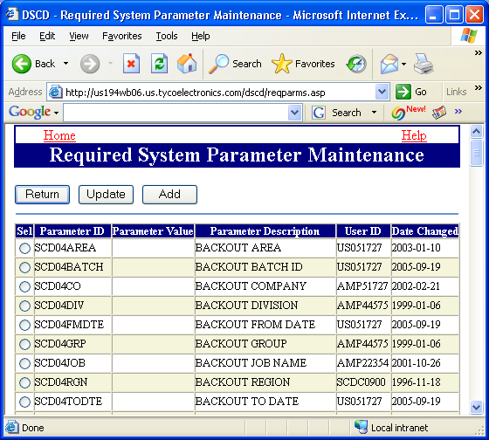
Parameters:
Backout Batch ID – (required) the Batch ID to backout

Backout From Date – (required) the Database_load_date to backout in dd-mon-yyyy format

Backout To Date – (required) to backout one or multiple days of data, enter the Database_load_date to backout in dd-mon-yyyy format

Note: There are other options to backout like by Area, Group, etc but I have not tried it. Please only use the by Batch ID option.

- Make sure to verify the entered parameters
- Login to solar using scd unix account. Password can be found at TDPI Passwords.xls excel file
- Execute the unix script at /d013/project/scd/scripts/scdu0400

How to Get the Database Load Date
- Logon to TOAD using SCD_SOURCE account. Password can be found at TDPI Passwords.xls excel file
- Run the SQL below in TOAD to get the list of actual Database Load Date by Batch ID
select database_load_date,batch_id,count(*)
from order_item_shipment a, organizations_dmn b
WHERE a.organization_key_id=b.organization_key_id
and organization_id='1148'
AND RECORD_STATUS_CDE='C'
AND database_load_DATE>='20-sep-2005'
GROUP BY database_load_date,batch_id

→ replace 1148 with actual OrgID of the batch
→ replace 20-sep-2005 with Obligation Date minus 2 of the batch

Note: Normally Database Load Date is the same as Obligation Date in DQIF for the batch but sometimes it is not so the SQL above will tell the exact date.

Reload Process

Reload process is only needed if the replacement batch was already processed and the batch to be replaced was not backed out yet, meaning most or all of the shipments records of new batch were rejected since they are duplicates.

- To verify if the replacement batch is loaded or not do the How to Get the Database Load Date procedure which will have the following possibilities:
A - The new batch is not found because is not process yet
B – The new batch is not found because all records were rejected as duplicates
C – The record count of the new batch is far lesser than the shipments/deliveries summary in DQIF

Note: Possibility A will only happen because the DAF and/or SCD schedule has not process the replacement batch yet, in that case Reload Process is not required
- If B or C is true then do the Backout Process for the replacement batch
- Create the trigger file for the replacement batch using the daf unix account in /d014/oradata/daf/data/trigger_files_external folder and run the unix command below:

echo > DAF.43.SCD.12345.OrgID.trg

→ replace 12345 with actual replacement BatchID
→ replace OrgID with the actual OrgID of the batch to reload

Note: The trigger file created will be process by the existing SCD jobs schedule which will load the data into TEMP_ORDER_ITEM_OPEN table. Subsequent jobs will then process the same batch to load it into ORDER_ITEM_SHIPMENTS table.

